**Worksheet – 3.3**

**Student Name:** Vivek Kumar  **UID:** 21BCS8129

**Branch:** BE-CSE (LEET) **Section/Group:** 809/A

**Semester:** 4th **Date of Performance:** 11/05/2022

**Subject Name:** Programming in Python Lab  **Subject Code:** 20CSP-259

**1. Aim/Overview of the practical:**

1. Write a Python program to generate 26 text files named A.txt, B.txt, and so on up to Z.txt
2. Write a Python program to create a file where all letters of English alphabet are listed by specified number of letters on each line
3. Write a Python program to read a random line from a file.
4. Write a Python program to count the frequency of words in a file
5. Write a Python program to copy the contents of a file to another file

**2. Task to be done/ Which logistics used:**

1. Write a Python program to generate 26 text files named A.txt, B.txt, and so on up to Z.txt
2. Write a Python program to create a file where all letters of English alphabet are listed by specified number of letters on each line
3. Write a Python program to read a random line from a file.
4. Write a Python program to count the frequency of words in a file
5. Write a Python program to copy the contents of a file to another file

**3. Steps for experiment/practical/Code:**

1. Write a Python program to generate 26 text files named A.txt, B.txt, and so on up to Z.txt.

import string

import os

if not os.path.exists("letters"):

os.makedirs("letters")

for letter in string.ascii_uppercase:

with open(letter + ".txt", "w") as f:

f.writelines(letter)

1. Write a Python program to create a file where all letters of English alphabet are listed by specified number of letters on each line.

import string

def letters_file_line(n):

with open("words1.txt", "w") as f:

alphabet = string.ascii_uppercase

letters = [alphabet[i:i + n] + "\n" for i in range(0, len(alphabet), n)]

f.writelines(letters)

letters_file_line(6)

1. Write a Python program to read a random line from a file.

import random

def random_line(fname):

lines = open(fname).read().splitlines()

return random.choice(lines)

print(random_line('filef1.txt'))

1. Write a Python program to count the frequency of words in a file.

from collections import Counter

def word_count(fname):

with open(fname) as f:

return Counter(f.read().split())

print("Number of words in the file :", word_count("filef1.txt"))

1. Write a Python program to copy the contents of a file to another file.

print("Enter the Name of Source File: ")

sFile = input()

print("Enter the Name of Target File: ")

tFile = input()

fileHandle = open(sFile, "r")

texts = fileHandle.readlines()

fileHandle.close()

fileHandle = open(tFile, "w")

for s in texts:

fileHandle.write(s)

fileHandle.close()

print("\nFile Copied Successfully!")

**4. Result/Output/Writing Summary:**

1. Write a Python program to generate 26 text files named A.txt, B.txt, and so on up to Z.txt.

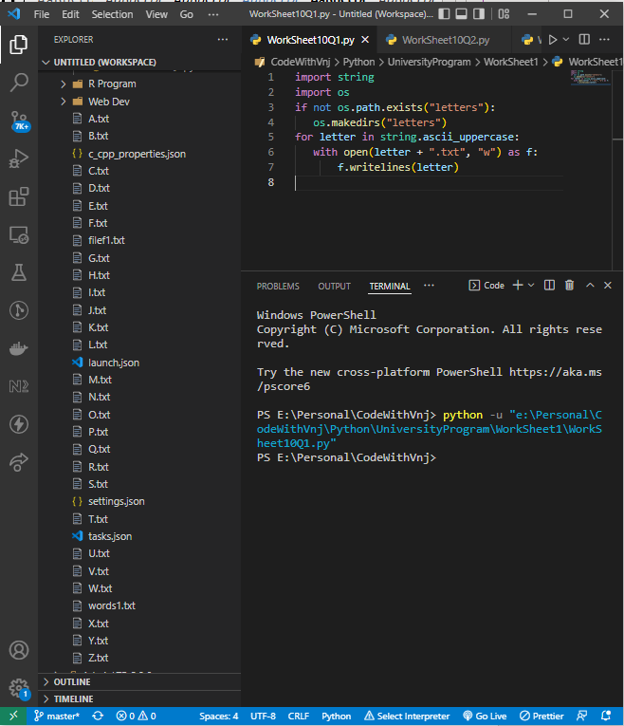

1. Write a Python program to create a file where all letters of English alphabet are listed by specified number of letters on each line.

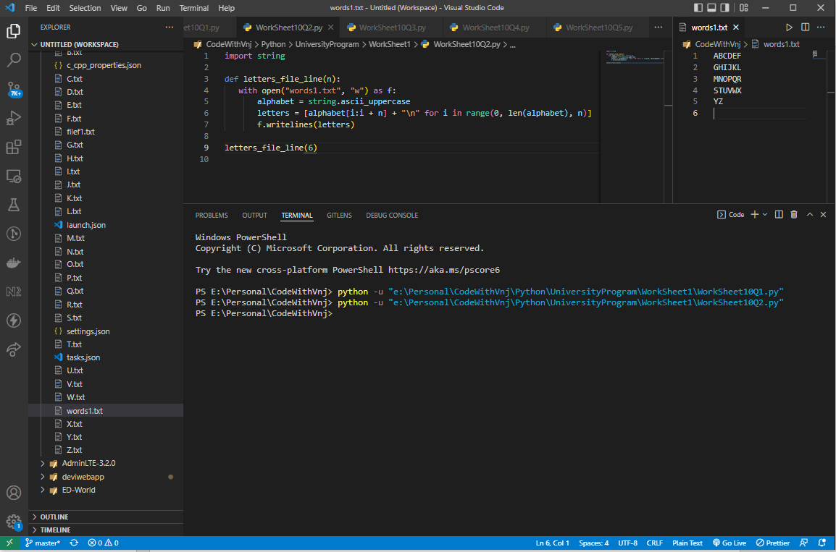

1. Write a Python program to read a random line from a file.

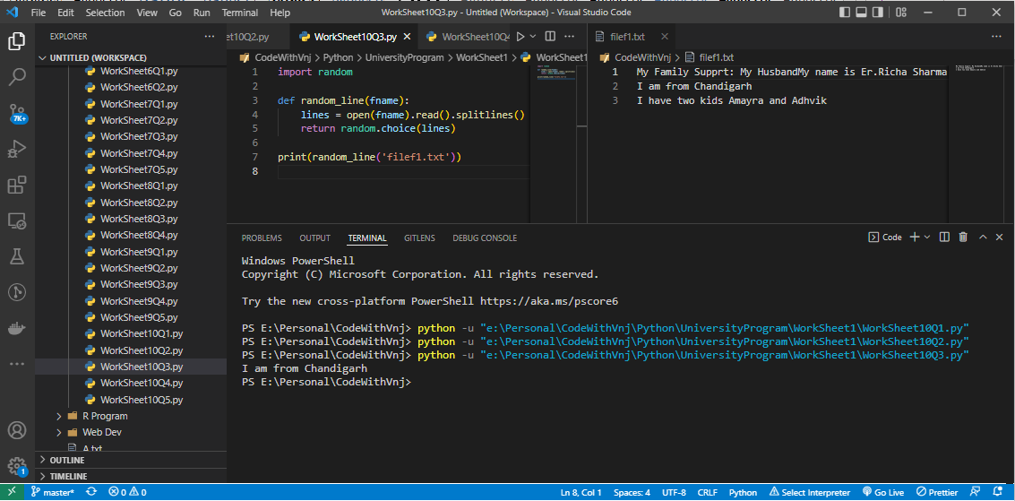

1. Write a Python program to count the frequency of words in a file.

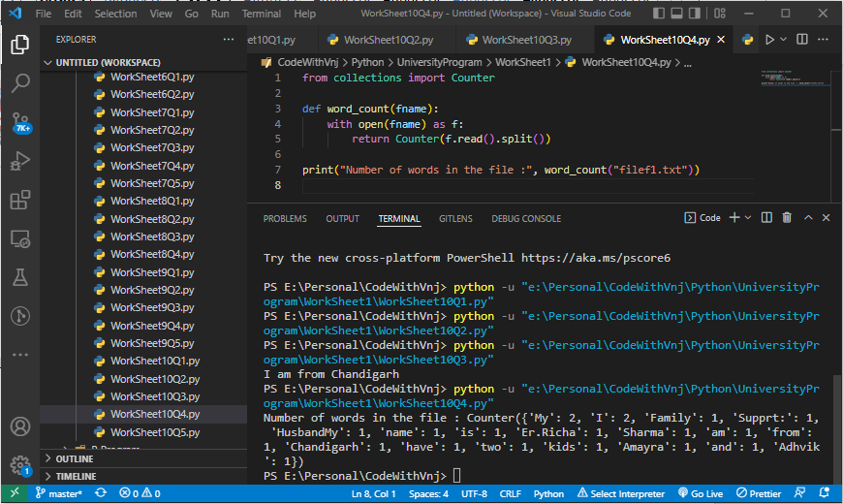

1. Write a Python program to copy the contents of a file to another file.

**Before run**

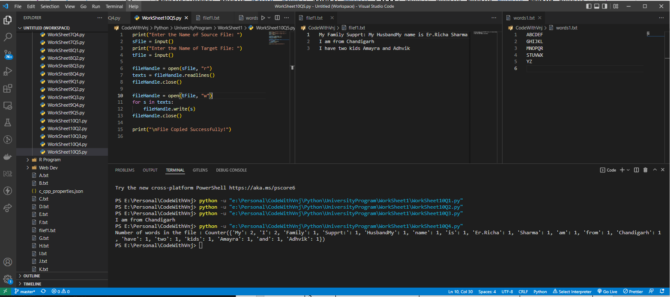

**After Running:**

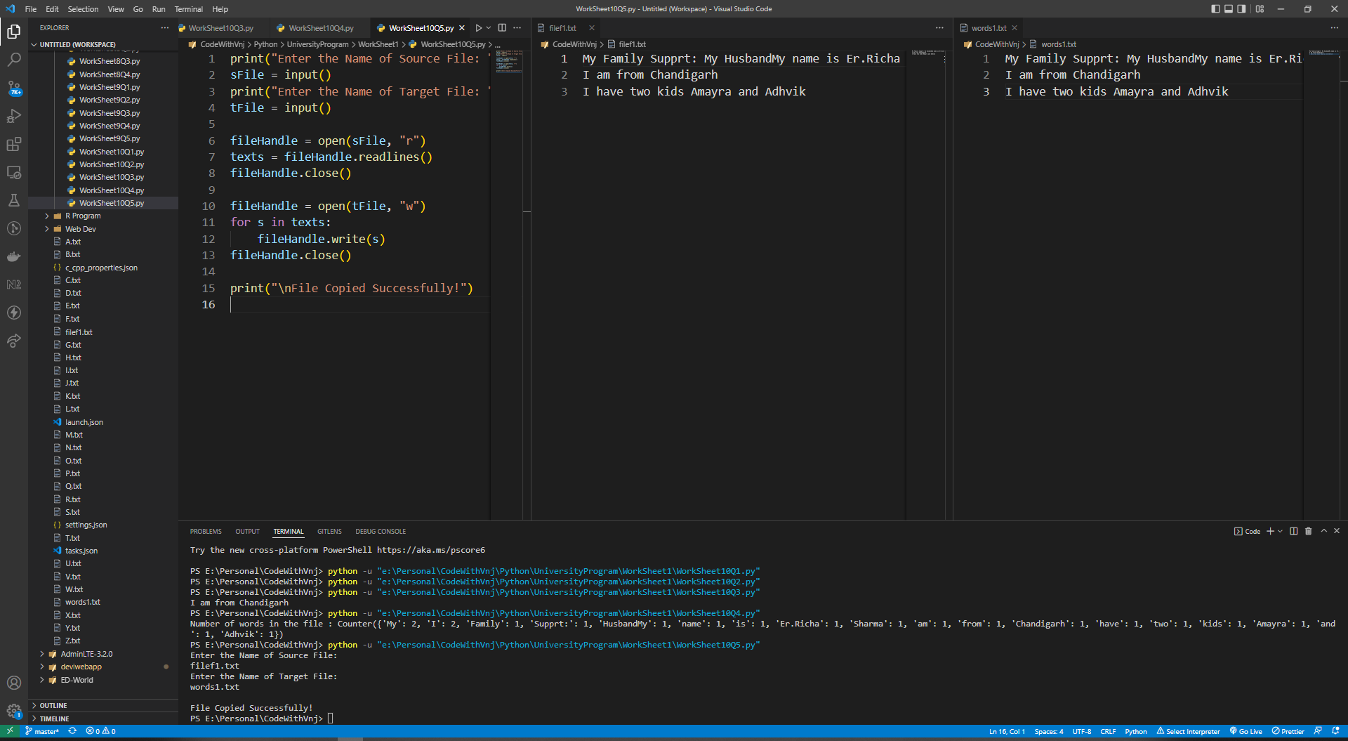

**Learning outcomes (What I have learnt):**

* 1. I have learnt, how to create the and manipulate the files.
  2. I have learnt how to do all operation with python.

**Evaluation Grid (To be created as per the SOP and Assessment guidelines by the faculty):**

|  |  |  |  |
| --- | --- | --- | --- |
| Sr. No. | Parameters | Marks Obtained | Maximum Marks |
| 1. |  |  |  |
| 2. |  |  |  |
| 3. |  |  |  |
| 4. |  |  |  |